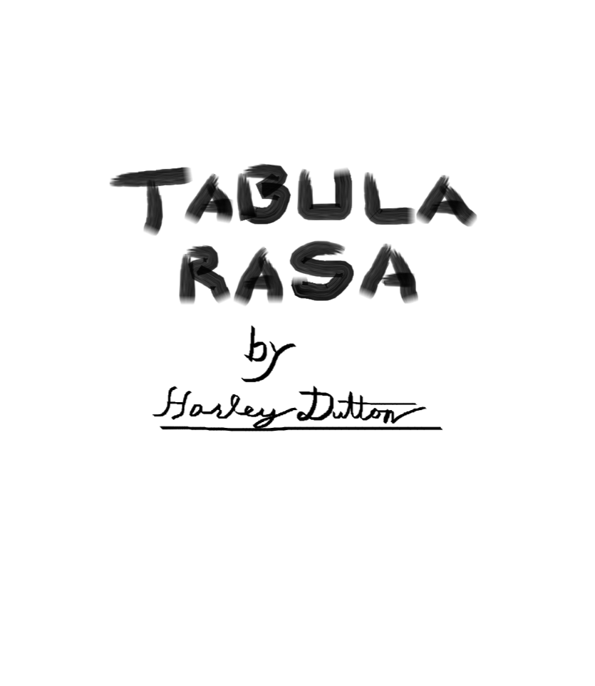

# **Introduction**

Tabula Rasa is a worldbuilding framework and a rules-light, generic roleplaying game that lets players create their own skills and add to the setting easily.

The worldbuilding framework produces a Setting. Settings are short, standardized, and easily sharable descriptions of a single place within a world. The intent is that Settings can be used to quickly understand a part of the world such that a player can create a Character or the Storyteller can create an Adventure.

The roleplaying system is generic so it will work with any Setting produced by the worldbuilding framework. The rules are minimal meaning you and your group should be able to create any character imaginable within the Setting and start playing very quickly!

## **Getting Started**

A night of roleplaying usually lasts anywhere from two to six hours and includes a variety of scenes: Exhilarating chases, nail-biting espionage, terrifying battles, grand speeches, descriptions of exotic lands, and of course joking around in and out of character are all hallmarks of good roleplaying.

One player will need to be the storyteller. The storyteller is largely responsible for running the game. A storyteller's responsibilities include setting up scenes between characters, planning and narrating events that drive the story, roleplaying NPCs, setting check difficulties, and managing the setting. Once a storyteller is chosen they should go take a look at the [setting](https://github.com/harleydutton/Tabula-Rasa/blob/develop/tabula-rasa.md#setting) section and either create or find a setting for their story.

Everyone else will be a player. Players should go straight to the [character_creation](https://github.com/harleydutton/Tabula-Rasa/blob/develop/tabula-rasa.md#character-creation) section and begin creating characters using the setting provided by the storyteller. Once a player has a character, they will provide voice acting, motivations, and personality for the character in addition to controlling their actions in the story.

Most good stories include conflict. Once you have a storyteller, a setting, a story, and a character for each player you will need to know how to resolve conflicts. Conflicts are usually between characters and when they arise they can be resolved by rolling [checks](https://github.com/harleydutton/Tabula-Rasa/blob/develop/tabula-rasa.md#check). Everyone should make sure they understand how checks work.

## **Legend**

* examples of specific skills and flavor will be monospace in-line
* section specific keywords will be in bold
* sections will be referenced using [links](https://github.com/harleydutton/Tabula-Rasa/blob/develop/tabula-rasa.md#legend)
* larger examples will be quoted and appear under the relevant section with no header.
* interjections (like this) will be in parenthesis because hyphens format badly.

## **Table of Contents**

* [Introduction](https://github.com/harleydutton/Tabula-Rasa/blob/develop/tabula-rasa.md#introduction)
  + [Getting Started](https://github.com/harleydutton/Tabula-Rasa/blob/develop/tabula-rasa.md#getting-started)
  + [Legend](https://github.com/harleydutton/Tabula-Rasa/blob/develop/tabula-rasa.md#legend)
  + [Table of Contents](https://github.com/harleydutton/Tabula-Rasa/blob/develop/tabula-rasa.md#table-of-contents)
* [Systems](https://github.com/harleydutton/Tabula-Rasa/blob/develop/tabula-rasa.md#systems)
  + [Character Creation](https://github.com/harleydutton/Tabula-Rasa/blob/develop/tabula-rasa.md#character-creation)
    - [Identification Information](https://github.com/harleydutton/Tabula-Rasa/blob/develop/tabula-rasa.md#identification-information)
    - [Action Delay](https://github.com/harleydutton/Tabula-Rasa/blob/develop/tabula-rasa.md#action-delay)
    - [Remaining Character Points](https://github.com/harleydutton/Tabula-Rasa/blob/develop/tabula-rasa.md#remaining-character-points)
    - [Motivations](https://github.com/harleydutton/Tabula-Rasa/blob/develop/tabula-rasa.md#motivations)
    - [Aesthetic Description](https://github.com/harleydutton/Tabula-Rasa/blob/develop/tabula-rasa.md#aesthetic-description)
    - [Flavor](https://github.com/harleydutton/Tabula-Rasa/blob/develop/tabula-rasa.md#flavor)
    - [Hooks and Boons](https://github.com/harleydutton/Tabula-Rasa/blob/develop/tabula-rasa.md#hooks-and-boons)
    - [Skills](https://github.com/harleydutton/Tabula-Rasa/blob/develop/tabula-rasa.md#skills)
      * [Mandatory Skills](https://github.com/harleydutton/Tabula-Rasa/blob/develop/tabula-rasa.md#mandatory-skills)
      * [Available Skills](https://github.com/harleydutton/Tabula-Rasa/blob/develop/tabula-rasa.md#available-skills)
      * [Recommended Skills](https://github.com/harleydutton/Tabula-Rasa/blob/develop/tabula-rasa.md#recommended-skills)
    - [Adding to the Setting](https://github.com/harleydutton/Tabula-Rasa/blob/develop/tabula-rasa.md#adding-to-the-setting)
      * [Veto](https://github.com/harleydutton/Tabula-Rasa/blob/develop/tabula-rasa.md#veto)
      * [Theme](https://github.com/harleydutton/Tabula-Rasa/blob/develop/tabula-rasa.md#theme)
      * [Scope](https://github.com/harleydutton/Tabula-Rasa/blob/develop/tabula-rasa.md#scope)
      * [Limiting Factors](https://github.com/harleydutton/Tabula-Rasa/blob/develop/tabula-rasa.md#limiting-factors)
      * [Uniqueness](https://github.com/harleydutton/Tabula-Rasa/blob/develop/tabula-rasa.md#uniqueness)
    - [NPCs](https://github.com/harleydutton/Tabula-Rasa/blob/develop/tabula-rasa.md#npcs)
    - [Printable Character Sheet](https://github.com/harleydutton/Tabula-Rasa/blob/develop/tabula-rasa.md#printable-character-sheet)
  + [Checks](https://github.com/harleydutton/Tabula-Rasa/blob/develop/tabula-rasa.md#checks)
    - [Difficulty](https://github.com/harleydutton/Tabula-Rasa/blob/develop/tabula-rasa.md#difficulty)
    - [Nested Checks](https://github.com/harleydutton/Tabula-Rasa/blob/develop/tabula-rasa.md#nested-checks)
    - [Contests](https://github.com/harleydutton/Tabula-Rasa/blob/develop/tabula-rasa.md#contests)
    - [DTMS Checks](https://github.com/harleydutton/Tabula-Rasa/blob/develop/tabula-rasa.md#dtms-checks)
    - [Challenging](https://github.com/harleydutton/Tabula-Rasa/blob/develop/tabula-rasa.md#challenging)
  + [Character Progression](https://github.com/harleydutton/Tabula-Rasa/blob/develop/tabula-rasa.md#character-progression)
    - [Character Point Acquisition](https://github.com/harleydutton/Tabula-Rasa/blob/develop/tabula-rasa.md#character-point-acquisition)
    - [Flavor Acquisition](https://github.com/harleydutton/Tabula-Rasa/blob/develop/tabula-rasa.md#flavor-acquisition)
      * [Crafting](https://github.com/harleydutton/Tabula-Rasa/blob/develop/tabula-rasa.md#crafting)
    - [Skill Acquisition](https://github.com/harleydutton/Tabula-Rasa/blob/develop/tabula-rasa.md#skill-acquisition)
    - [Skill Progression](https://github.com/harleydutton/Tabula-Rasa/blob/develop/tabula-rasa.md#skill-progression)
      * [Mandatory Skills Progression](https://github.com/harleydutton/Tabula-Rasa/blob/develop/tabula-rasa.md#mandatory-skills-progression)
      * [Available Skills Progression](https://github.com/harleydutton/Tabula-Rasa/blob/develop/tabula-rasa.md#available-skills-progression)
  + [Money](https://github.com/harleydutton/Tabula-Rasa/blob/develop/tabula-rasa.md#money)
    - [Trivial Purchases](https://github.com/harleydutton/Tabula-Rasa/blob/develop/tabula-rasa.md#trivial-purchases)
    - [Minor Purchases](https://github.com/harleydutton/Tabula-Rasa/blob/develop/tabula-rasa.md#minor-purchases)
    - [Major Purchases](https://github.com/harleydutton/Tabula-Rasa/blob/develop/tabula-rasa.md#major-purchases)
    - [Impossible Purchases](https://github.com/harleydutton/Tabula-Rasa/blob/develop/tabula-rasa.md#impossible-purchases)
  + [Hidden Information](https://github.com/harleydutton/Tabula-Rasa/blob/develop/tabula-rasa.md#hidden-information)
    - [Unsuspicious](https://github.com/harleydutton/Tabula-Rasa/blob/develop/tabula-rasa.md#unsuspicious)
    - [Undetected](https://github.com/harleydutton/Tabula-Rasa/blob/develop/tabula-rasa.md#undetected)
    - [Suspicious](https://github.com/harleydutton/Tabula-Rasa/blob/develop/tabula-rasa.md#suspicious)
    - [Detected](https://github.com/harleydutton/Tabula-Rasa/blob/develop/tabula-rasa.md#detected)
  + [Influence](https://github.com/harleydutton/Tabula-Rasa/blob/develop/tabula-rasa.md#influence)
    - [Social Influence](https://github.com/harleydutton/Tabula-Rasa/blob/develop/tabula-rasa.md#social-influence)
      * [Difficulty](https://github.com/harleydutton/Tabula-Rasa/blob/develop/tabula-rasa.md#difficulty-1)
      * [Resistance](https://github.com/harleydutton/Tabula-Rasa/blob/develop/tabula-rasa.md#resistance)
    - [Mental Influence](https://github.com/harleydutton/Tabula-Rasa/blob/develop/tabula-rasa.md#mental-influence)
      * [Difficulty](https://github.com/harleydutton/Tabula-Rasa/blob/develop/tabula-rasa.md#difficulty-2)
      * [Resistance](https://github.com/harleydutton/Tabula-Rasa/blob/develop/tabula-rasa.md#resistance-1)
  + [Combat](https://github.com/harleydutton/Tabula-Rasa/blob/develop/tabula-rasa.md#combat)
    - [Intent](https://github.com/harleydutton/Tabula-Rasa/blob/develop/tabula-rasa.md#intent)
    - [Rolling Initiative](https://github.com/harleydutton/Tabula-Rasa/blob/develop/tabula-rasa.md#rolling-initiative)
    - [Turns](https://github.com/harleydutton/Tabula-Rasa/blob/develop/tabula-rasa.md#turns)
      * [Major Actions](https://github.com/harleydutton/Tabula-Rasa/blob/develop/tabula-rasa.md#major-actions)
        + [Attacking](https://github.com/harleydutton/Tabula-Rasa/blob/develop/tabula-rasa.md#attacking)
        + [advantages and disadvantages](https://github.com/harleydutton/Tabula-Rasa/blob/develop/tabula-rasa.md#advantages-and-disadvantages)
        + [Interactions](https://github.com/harleydutton/Tabula-Rasa/blob/develop/tabula-rasa.md#interactions)
      * [Move Actions](https://github.com/harleydutton/Tabula-Rasa/blob/develop/tabula-rasa.md#move-actions)
        + [Zones](https://github.com/harleydutton/Tabula-Rasa/blob/develop/tabula-rasa.md#zones)
        + [Dodging](https://github.com/harleydutton/Tabula-Rasa/blob/develop/tabula-rasa.md#dodging)
      * [Reactions](https://github.com/harleydutton/Tabula-Rasa/blob/develop/tabula-rasa.md#reactions)
        + [Counterattacks](https://github.com/harleydutton/Tabula-Rasa/blob/develop/tabula-rasa.md#counterattacks)
        + [Defensive Actions](https://github.com/harleydutton/Tabula-Rasa/blob/develop/tabula-rasa.md#defensive-actions)
      * [Free Actions](https://github.com/harleydutton/Tabula-Rasa/blob/develop/tabula-rasa.md#free-actions)
    - [Transitions](https://github.com/harleydutton/Tabula-Rasa/blob/develop/tabula-rasa.md#transitions)
    - [Entering and Leaving combat](https://github.com/harleydutton/Tabula-Rasa/blob/develop/tabula-rasa.md#entering-and-leaving-combat)
    - [War](https://github.com/harleydutton/Tabula-Rasa/blob/develop/tabula-rasa.md#war)
* [Setting](https://github.com/harleydutton/Tabula-Rasa/blob/develop/tabula-rasa.md#setting)
  + [Action Delay](https://github.com/harleydutton/Tabula-Rasa/blob/develop/tabula-rasa.md#action-delay-1)
  + [Character Points](https://github.com/harleydutton/Tabula-Rasa/blob/develop/tabula-rasa.md#character-points)
  + [Common/Available skills](https://github.com/harleydutton/Tabula-Rasa/blob/develop/tabula-rasa.md#commonavailable-skills)
  + [Mandatory Skills](https://github.com/harleydutton/Tabula-Rasa/blob/develop/tabula-rasa.md#mandatory-skills-1)
  + [Technology and Magic Descriptions](https://github.com/harleydutton/Tabula-Rasa/blob/develop/tabula-rasa.md#technology-and-magic-descriptions)
  + [Store](https://github.com/harleydutton/Tabula-Rasa/blob/develop/tabula-rasa.md#store)
  + [Tone](https://github.com/harleydutton/Tabula-Rasa/blob/develop/tabula-rasa.md#tone)
  + [Social Description](https://github.com/harleydutton/Tabula-Rasa/blob/develop/tabula-rasa.md#social-description)
  + [Physical Description](https://github.com/harleydutton/Tabula-Rasa/blob/develop/tabula-rasa.md#physical-description)
  + [Theme](https://github.com/harleydutton/Tabula-Rasa/blob/develop/tabula-rasa.md#theme-1)
* [Character](https://github.com/harleydutton/Tabula-Rasa/blob/develop/tabula-rasa.md#character)
  + [Identification Information](https://github.com/harleydutton/Tabula-Rasa/blob/develop/tabula-rasa.md#identification-information-1)
    - [Your Name](https://github.com/harleydutton/Tabula-Rasa/blob/develop/tabula-rasa.md#your-name)
    - [Story](https://github.com/harleydutton/Tabula-Rasa/blob/develop/tabula-rasa.md#story)
    - [Concept](https://github.com/harleydutton/Tabula-Rasa/blob/develop/tabula-rasa.md#concept)
    - [Setting Name](https://github.com/harleydutton/Tabula-Rasa/blob/develop/tabula-rasa.md#setting-name)
    - [Character name](https://github.com/harleydutton/Tabula-Rasa/blob/develop/tabula-rasa.md#character-name)
  + [Action Delay](https://github.com/harleydutton/Tabula-Rasa/blob/develop/tabula-rasa.md#action-delay-2)
  + [Character Points](https://github.com/harleydutton/Tabula-Rasa/blob/develop/tabula-rasa.md#character-points-1)
  + [Motivations](https://github.com/harleydutton/Tabula-Rasa/blob/develop/tabula-rasa.md#motivations-1)
  + [Skills](https://github.com/harleydutton/Tabula-Rasa/blob/develop/tabula-rasa.md#skills-1)
    - [Mandatory Skills](https://github.com/harleydutton/Tabula-Rasa/blob/develop/tabula-rasa.md#mandatory-skills-2)
    - [Available Skills](https://github.com/harleydutton/Tabula-Rasa/blob/develop/tabula-rasa.md#available-skills-1)
  + [Flavor](https://github.com/harleydutton/Tabula-Rasa/blob/develop/tabula-rasa.md#flavor-1)
    - [Acquisition](https://github.com/harleydutton/Tabula-Rasa/blob/develop/tabula-rasa.md#acquisition)
    - [Bad Flavor](https://github.com/harleydutton/Tabula-Rasa/blob/develop/tabula-rasa.md#bad-flavor)
    - [Deals](https://github.com/harleydutton/Tabula-Rasa/blob/develop/tabula-rasa.md#deals)
    - [Items](https://github.com/harleydutton/Tabula-Rasa/blob/develop/tabula-rasa.md#items)
    - [Money](https://github.com/harleydutton/Tabula-Rasa/blob/develop/tabula-rasa.md#money-1)
    - [Social Flavor](https://github.com/harleydutton/Tabula-Rasa/blob/develop/tabula-rasa.md#social-flavor)
    - [Supernatural Flavor](https://github.com/harleydutton/Tabula-Rasa/blob/develop/tabula-rasa.md#supernatural-flavor)
    - [Relationships](https://github.com/harleydutton/Tabula-Rasa/blob/develop/tabula-rasa.md#relationships)
    - [Knowledge](https://github.com/harleydutton/Tabula-Rasa/blob/develop/tabula-rasa.md#knowledge)
    - [Vehicles and Properties](https://github.com/harleydutton/Tabula-Rasa/blob/develop/tabula-rasa.md#vehicles-and-properties)
    - [Physical](https://github.com/harleydutton/Tabula-Rasa/blob/develop/tabula-rasa.md#physical)
* [Glossary of Terms](https://github.com/harleydutton/Tabula-Rasa/blob/develop/tabula-rasa.md#glossary-of-terms)

# **Systems**

This section goes into detail on the typical systems involved in roleplaying and how this game choses to do them instead. Some of these will be very far from typical given that there is no source material to reference for skills, items, monsters, etc.

## **Character Creation**

To make a character first read through the setting document your storyteller has provided you with. When you have done this and understand the world you will be playing in read through this and fill in the sections for the character sheet--located at the end of this section--using what you have learned. Ask your storyteller for help with things you do not understand or consult the table of contents.

### **Identification Information**

These things go on your sheet to keep you and your storyteller sane in real life. You can omit these things if you like but it is not recommended and I already carved out some space on the sheet for it.

* Name: The character's name
* Player: The player's name
* Setting: The name of the character's setting
* Story: The name of the story the character was in
* Concept:

### **Action Delay**

This is how long your character has to wait to do things in combat. Lower means faster. If you would like to decrease your action delay you can do so by spending CP. The typical default action delay is 10 but you should take a look at the setting document provided by your storyteller to make sure.

|  | **Default** | **-1 AD** | **-2 AD** | **-3 AD** | **-4 AD** | **-5 AD** | **-X AD** |
| --- | --- | --- | --- | --- | --- | --- | --- |
| Cost for -1 AD | 0 | 1 CP | 4 CP | 9 CP | 16 CP | 25 CP | X*X CP |
| Total cost | 0 | 1 CP | 5 CP | 14 CP | 30 CP | 55 CP | ... |

### **Remaining Character Points**

The storyteller should be tracking the CP they have distributed to the group on the setting document. Each player should be keeping track of how much of this they have not spent on their character sheet such that they can easily take new skills.

### **Motivations**

Tell me why your character gets out of bed in the morning. What is their purpose? Do they seek revenge? To protect something? Are they on the run? Do they want to be respected? Are they searching for something? Do they have any ideals that they follow? These are all motivations that will give a storyteller a good way to interact with your character. You must have at least one and you should consider taking a few.

### **Aesthetic Description**

This is a good place to describe your character's gender, age, weight, build, height, bearing, clothes, stereotypical class, etc. The purpose of this section is to give other players or the storyteller an idea of what your character looks and acts like. If you want anything here to influence your rolls it should also be added to flavor.

### **Flavor**

Flavor is a word or short phrase describing your character. While you could say your character has clothes and the ability to speak, let’s not worry about that and instead focus on the things that spice your character up! Flavor can include knowledge, possessions, physique, and even social position. Most flavor costs one CP at character creation or one hook for those which are particularly powerful. More flavor can be obtained or inflicted later on in the game.

### **Hooks and Boons**

Character hooks, or hooks for short, are a way to get boons and give the storyteller a way to pull you further into the story. A hook is anything that allows the storyteller to motivate your character specifically. A hook can be a love interest, an enemy, a debt, a cause, a disability, and much more. Boons, on the other hand, are rewards that are unobtainable except through hooks and roleplaying. Both hooks and boons can be anything but usually end up being flavor. The storyteller must agree to grant you the boon you want or either of the boon and major purchase flavors for the hook you are offering; be reasonable. The flavors boon and major purchase are equal in value and can be converted. Speak with your storyteller to trade these flavors for boons or things from the major purchase column of the setting's store.

### **Skills**

Skills are the most mechanical part of a character. They allow your character to make actions by rolling checks. Skills have levels and are usually self-descriptively named though there is space for skill descriptions on the character sheet. You can purchase skills with CP at character creation and level them up later using CP.

lock-picking, pyromancy, lying, and blocking are all examples of skills.

#### **Mandatory Skills**

Mandatory skills are Body, Mind, Spirit and Social. They are the most broad skills in each of their respective categories which are physical, mental, magical, and... social. These skills can be used to roll any check in their category but scale differently than every other skill. All characters get one level in each mandatory skill for free just in case they have to make a check they don't have an appropriate skill for.

| **Level** | **1** | **2** | **3** | **4** | **5** | **X** |
| --- | --- | --- | --- | --- | --- | --- |
| CP Cost | 0 CP | 4 CP | 9 CP | 16 CP | 25 CP | X*X CP |
| Total CP | 0 CP | 4 CP | 13 CP | 29 CP | 54 CP | ... |

#### **Available Skills**

Available skills are those listed on the setting. This should include all of the skills the players or storyteller have added to the setting. These skills are available within the setting to any character passing a DTMS check and can be purchased as normal.

| **Level** | **1** | **2** | **3** | **4** | **5** | **X+1** |
| --- | --- | --- | --- | --- | --- | --- |
| CP Cost | 1 CP | 2 CP | 3 CP | 4 CP | 5 CP | X CP |
| Total CP | 1 CP | 3 CP | 6 CP | 10 CP | 15 CP | ... |

#### **Recommended Skills**

Even though the mandatory skills should have you covered having some way to attack, defend, sense, communicate, and disagree is a good idea.

For physical skills athletics, acrobatics, endurance, and weapon skills are all fairly useful. For mental skills intelligence, memory, and willpower are all quite useful. Spirit is optional but if your storyteller is allowing magic you should pick a magic school so you can do more interesting magic. For social skills bartering, persuasion, seduction, lying, leadership, and intimidation are all classics.

### **Adding to the Setting**

It is the intent of this system that you can play what you want. Players can speak with the storyteller and propose things to be added to the setting. If you want to play a cat-man samurai talk to the storyteller about adding cat-men to the setting and if samurai need special skills or tools to be relevant, propose those too. If the storyteller agrees, "Boom!", you can play what you want.

#### **Veto**

The storyteller can reject your additions to the setting for any reason. You can bitch and moan but ultimately the storyteller is the one telling the story and doesn't have to put your idea in the story no matter how much you want it there. Come up with a new idea.

@Storyteller: In the interest of reducing arguing, bitching, and moaning, give a reason for your veto.

#### **Theme**

A common reason for an addition to a setting to be rejected is because of theme. Don't try to play a wizard in a non-magic setting. Don't try to play a jedi in a medieval setting. Sure there are storytellers who will jump at that but try to stay within the themes outlined in the setting document.

#### **Scope**

Many times, players will try to create skills that are much too broad in scope. Less frequently, players will make skills that are too narrow in scope. Loosely speaking scope represents the percentage of situations a skill can apply to. An example of a skill that is too broad is magic as you can do anything you want with it. A skill that is too narrow would be death curse as it can only be used to kill someone. Somewhere in between we find the skill death magic which has many applications but not infinitely many. It has a specific domain in which it is useful. Storytellers should specifically look out for skills that are too broad during character creation and veto them.

#### **Limiting Factors**

If you create a skill with appropriate scope that is just too powerful for the setting or story (most magic skills) your storyteller may inflict a few limiting factors upon the skill you have proposed or your character.

@Storyteller: A few good limiting factors are timing restrictions(requires multiple turns in combat, cannot be done in combat, takes multiple days, etc.), resource costs (add a mana bar, minor purchases, major purchases, etc.), context restrictions (must have line of sight, must have eye contact, must be touching the target, must have a piece of the target, etc.), and cooldowns (AUTs or turns, once per combat, once per day, refreshes randomly, etc.).

#### **Uniqueness**

When you add something to the setting you may have it in your head that it will be unique. You will be the only fire mage, you will have the only gun, you will be the only alien, etc. This can very quickly lead to an unbalanced and unenjoyable setting or story. Do not expect to have a monopoly on anything you add to the setting. Where there is one, there can be two.

### **NPCs**

Tabula treats NPCs the same as every other character. Make a character sheet for them. If they need to be combat capable make sure they have an AD. If they are there to talk make sure they have *at least* one motivation. Give them CP based on how much you have given the players. It is a good idea to leave a large chunk of an NPCs CP unspent.

### **Printable Character Sheet**

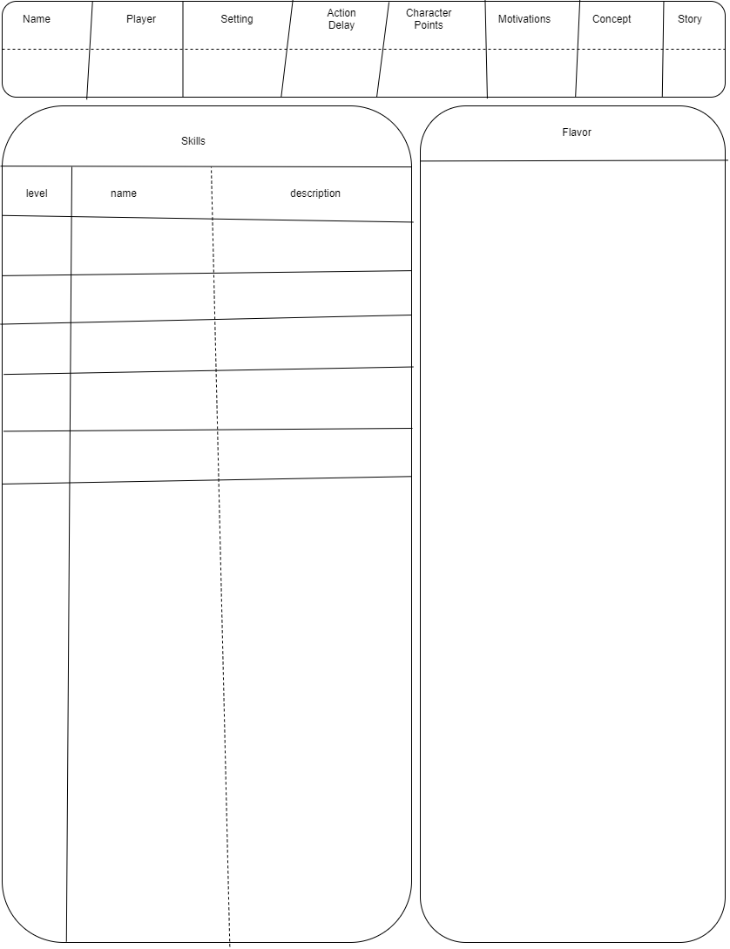

## **Checks**

When conflict occurs during roleplaying, most of the time, the fairest way to resolve it is by rolling a skill check, or check for short. You can always use one of the mandatory skills (mind, body, spirit, and social) or you can use another relevant skill your character has. Tell the storyteller what you want to do with your skill and feel free to be specific--Actually specific is better. The storyteller will set a subjective difficulty (target number) for the action. At this point you have options. You can roll, abort, or challenge the difficulty the storyteller set. Roll a number of dice equal the skill's level. If any beat the target number you pass the check and what you described happens.

If Sam wants to stab a goblin and sam has a fencing skill of 5, Sam would say "I want to skewer the goblin through the heart with my rapier!". The storyteller tells him "that will be hard" which means the target number is 6. If any one of Sam's 5 dice come up as a 6, Sam kills the goblin.

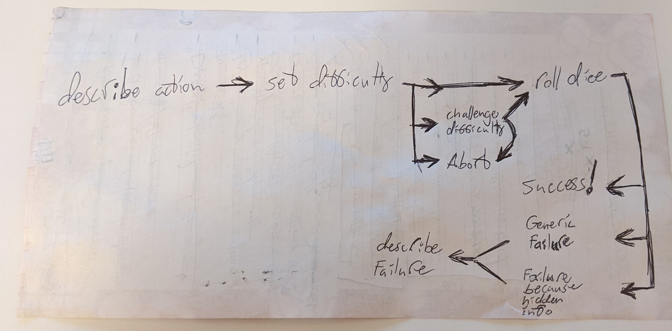

### **Difficulty**

The storyteller can assign a check five different difficulties: Trivial, Easy, Normal, Hard, and Impossible. The difficulty of a skill check can be modified by flavor, context, or the innate ease or difficulty of the action itself. The storyteller decides if any of these things is meaningful enough to change the difficulty. The subjective difficulty of a roll translates directly to a target number, meaning when you roll a check only dice that are greater than or equal to the target number count as successes. The players can challenge the difficulty the storyteller has prescribed if they wish. If this happens everyone votes on the desired difficulty and the storyteller wins ties.

| **Difficulty** | **Trivial** | **Easy** | **Normal** | **Hard** | **Impossible** |
| --- | --- | --- | --- | --- | --- |
| Target Number | Automatic Pass | 4 | 5 | 6 | Automatic Fail |

### **Nested Checks**

When you want to perform an action involving multiple different skills you might have to make a nested skill check. What this means is that you roll a check for each skill involved and if any of them fail the action fails. If they all succeed the action succeeds.

To back flip down some stairs while shooting a fireball up the stairs you would need to pass both acrobatics and fire magic checks.

### **Contests**

Contests are where two or more characters are trying to be best at some action. The problem comes in that there is a good chance both characters will succeed and so we must use magnitude of success to determine the winner of the contest. You only need one success to pass a skill check. Any successes beyond one contribute to magnitude of success. The character with the highest magnitude of success wins the contest.

Racing, feats of strength, public debates, drinking contents, and gambling are all common contests.

### **DTMS Checks**

There is one special kind of check that the storyteller will make frequently. These are DTMS checks which stands for "Does this make sense?" They don't use dice and they aren't a check in the traditional sense. DTMS checks are just a way for me to shorthand the idea "use your brain to decide if this should be allowed or not."

### **Challenging**

When a player disagrees with the difficulty of a check they can challenge the difficulty the storyteller has set. Effectively this is asking the table to vote for what they think the difficulty should be. The storyteller's vote counts as 1.5. The purpose of this system is to deal with storytellers who are a little unfair some of the time, not make all checks Easy.

## **Character Progression**

Characters usually get stronger over the course of a story. They can acquire new skills, level up the existing ones, and get new flavor including but not limited to items, social status, and followers.

### **Character Point Acquisition**

Character points are given by the storyteller at character creation and usually also session by session. Character points are typically awarded for heroics, good roleplaying, and completing quests. The storyteller should keep a running total on the setting document of how many CP have been given out to the group.

### **Flavor Acquisition**

Your character will acquire flavor throughout the story for mostly for free. You can, however, pay for it in the same way as you would during character creation. Hooks and boons can be acquired through roleplaying, items and other things worth one CP can be obtained from stores where available, and temporary wound flavor is the natural result of combat. Beware, actions have consequences and sometimes flavor will be inflicted upon you.

#### **Crafting**

In Tabula, crafting an item is just a skill check. Describe what you want and how you plan on using your crafting skill to get it, ask the storyteller what the difficulty is, and make the roll. If you succeed you get the desired item, likely with some narrative flair. If you fail you do not get what you asked for, any materials and time put into the crafting roll are lost, and it is possible something bad happens.

### **Skill Acquisition**

Skills can be learned from other characters in the story. If a skill is fairly simple or if a character is fairly dedicated they can learn it on their own. Dedicated characters can also create new skills and add them to the setting--once again, only with storyteller approval. The first level of any new skill costs one character point. All skill acquisitions need to pass a DTMS check.

### **Skill Progression**

Leveling up skills can happen at any time and requires CP. The CP cost varies by level and type of skill. Mandatory skills are significantly more expensive than available skills to level up.

#### **Mandatory Skills Progression**

Mandatory skills are Body, Mind, Spirit and Social. The cost to level a mandatory skill is the desired level squared in CP. You must level up skills one level at a time.

| **Level** | **1** | **2** | **3** | **4** | **5** | **X** |
| --- | --- | --- | --- | --- | --- | --- |
| CP Cost | 0 CP | 4 CP | 9 CP | 16 CP | 25 CP | X*X CP |
| Total CP | 0 CP | 4 CP | 13 CP | 29 CP | 54 CP | ... |

#### **Available Skills Progression**

All other skills are available skills. The cost to level is the desired level in CP. You must level up skills one level at a time.

| **Level** | **1** | **2** | **3** | **4** | **5** | **X+1** |
| --- | --- | --- | --- | --- | --- | --- |
| CP Cost | 1 CP | 2 CP | 3 CP | 4 CP | 5 CP | X CP |
| Total CP | 1 CP | 3 CP | 6 CP | 10 CP | 15 CP | ... |

## **Money**

In Tabula money has been abstracted away as annoying bookkeeping. Many common items will be effectively free. When you actually have money it will usually be the flavor minor purchase or less commonly a major purchase. These purchases can be roleplayed as being whatever the native currency of the world is be it gold coins, bank notes, or space-bucks. To understand how these purchases will spend take a look at the store chart on your setting.

This is the store from Sequoia, the example setting.

| **Trivial** | **Minor** | **Major** | **Impossible** |
| --- | --- | --- | --- |
| food | armor | training | metal |
| water | weapons | ironwood |  |
| torches | tools | land |  |
| entertainment | animals | vehicles |  |
| consumables | luxuries | medicine |  |
| lodging | meat | AEther |  |
| booze | jewelry | magic items |  |
| clothes |  | allies |  |
| materials |  | boons |  |

### **Trivial Purchases**

Many common things characters will need are effectively free. The idea here is that each character has some way of paying for their adventures--usually a day-job or some savings--and they dip into this during the adventure and replenish it during downtime such that it comes out in the wash. Typically food, clothes, ammo, and lodging end up on the list of trivial purchases but a storyteller might want to make you sweat by making one of your basic needs non-trivial.

### **Minor Purchases**

The idea behind minor purchases is that while they aren't everyday purchases they are easy to get. Tools, weapons, vehicles, jewelry, and luxuries all typically fall into this category. You can convert your character's character points into minor purchases at a one-for-one ratio but you cannot typically convert them back. The minor purchase flavor can be used to pay for goods and services under the "minor" column of the setting's store. A character can have multiple copies of the minor purchase flavor.

### **Major Purchases**

Major purchases are very similar to minor purchases except that they are worth more. Typically, to obtain a major purchase, you will have to give the storyteller a hook for your character or give up a boon. The major purchase flavor can be used to pay for things in the "major" column of the setting's store. Leadership of an organization, elite training, property, and spaceships are all roughly the same value as the flavor major purchase. Furthermore, major purchases can also be used to pay off hooks or purchase new boons.

### **Impossible Purchases**

Lastly and of least importance we have impossible purchases. There isn't much to say here really. You typically can't obtain these things for one reason or another. They might be illegal, one-of-a-kind, insanely expensive, or simply non-existent in the setting.

## **Hidden Information**

Hidden information in roleplaying games can range from lying, to sneaking up on someone, to hiding things. Hidden info is a source of tension and surprise but resolving it can be tricky. The way I like to think about it there are two roles when talking about hidden information. One is the thief, the character going around hiding information. The other is the guard, the character trying to discover this information. The information the thief hides can be undiscovered or discovered. The guard can be suspicious or unsuspicious. Because it will almost certainly come up, it is worth noting that the difficulty of checks related to hidden information should be disclosed by default but doesn't have to be revealed before or even after the check is made. Whenever the thief wishes to hide info or change hidden info they need to make a check.

### **Unsuspicious**

Unsuspicious is a state for the guard and represents that the guard does not know the hidden information and doesn't even know it exists. This is the default state for every character.

### **Undetected**

Undetected is a state for the thief's hidden info and represents that the thief has successfully hidden it and that the guard might know it exists but hasn't detected it. When the thief wants to hide info or change hidden info, if there is a guard who could detect them, they need to pass a relevant check. Lying, stealth, disguise, traps, pickpocket, etc. are skills they might use.

Actions to hide information: Lying, moving silently, putting on a disguise, setting a trap, picking a pocket, etc.

### **Suspicious**

Suspicious represents the state where the guard knows the thief's hidden information exists but doesn't have it. At this point the guard can start making checks to attempt to uncover the hidden info. Pass or fail, when the guard stops looking for the information they should be considered unsuspicious. The guard might use seeing, hearing, some extra-sensory perception skill, a domain-specific skill like animal handling, or a mandatory skill to try and detect the hidden information.

Reasons to become suspicious: You are a guard on duty. Nervous stuttering, heard a noise, clothes don't fit well, saw a wire, felt something in pants, etc.

### **Detected**

The thief's hidden information has been detected by the guard. No further checks need to be made and the situation can be played out.

Discovered the thief's lie, saw the thief sneaking up, saw through the thief's disguise, saw the thief's trap, etc.

## **Influence**

When one character uses a skill to make another character do something the first character is exerting their influence. These situations can quickly break the game or make it unenjoyable unless there is counter play. This section defines a system for resolving these situations. For this section the salesman will be the character exerting influence and the mark will be the target of their influence.

### **Social Influence**

Social influence is when the salesman uses their demeanor and way with words to convince the mark to do their will. The skills social, persuasion, seduction, bartering, and intimidation are the usual suspects.

#### **Difficulty**

Before the salesman's influence check is made the storyteller should check the mark's motivations. Social influence checks are affected by the mark's [motivations](https://github.com/harleydutton/Tabula-Rasa/blob/develop/tabula-rasa.md#motivations) as well as flavor.

#### **Resistance**

Social influence is typically not resisted unless the character has a reason to do so. When influence social is resisted the mandatory skill social, or a more apt skill, is used to roll a check. The mark's [motivations](https://github.com/harleydutton/Tabula-Rasa/blob/develop/tabula-rasa.md#motivations) can have an effect on this check as well.

A guard has obvious reasons to not tell you about the secret entrance and should resist. A child has little reason not to carry your message to the mayor when you ask him.

### **Mental Influence**

Mental influence is when a salesman uses magic or some other plot device to subvert the will of the mark. The best example is mind control but others are madness, illusions, and emotion magic.

#### **Difficulty**

The mark's motivations are typically of little relevance in situations of mental influence. The mark's code of honor doesn't really come into play when they are told "go jump out a window."

#### **Resistance**

Mental influence is almost always resisted. When the salesman uses mind control and tells the mark "Give me your wallet.", the mark probably doesn't have a relevant motivation to influence their resistance roll but will definitely want to resist. Usually the mark resists by rolling a check with the mandatory skill mind or a more apt skill. Typically this check goes unmodified unless magic items or flavor are involved.

## **Combat**

This really isn't a section describing combat, but instead a section describing any extended competitive activity within a story where timing is incredibly important. Sword and gun fights certainly fit the mould, sure, but so do a number of other things like horse races, ritual summoning gone wrong, and trying to command a fleet with light-minutes of delay. Combat in this game is based on actions and cooldowns. Despite this these rules will focus on the more traditional combat and I will leave you, dear reader, to adapt them to your competitive pie-eating contests as necessary.

### **Intent**

The intent of combat in this system is to be dramatic. It isn't intended to be fair, realistic, or comprehensive. It is intended to be dramatic (and fun). Like the rest of the system players can have their characters do anything they think of. This means players can say "I would like to shoot that robot in the power core" with the reasonable expectation that the robot will be incapacitated if they they pass their shooting check. There are two problems with this. First, suddenly gaining the death flavor is well and good for henchmen but big-bad-evil-guys need time to monologue and should always be dealt the dying flavor instead. Second, again instant death is fine for henchmen but bosses and players should be harder to kill. Typically

henchmen but this is not a dramatic way for bosses to go out. The intent is to make it hard to kill named characters before their defences have been lowered. Once the boss robot's force field has been shorted out with a bucket of water then can be dealt some form of the dying flavor at normal difficulty and finished off as an action or once combat ends.

Combat in Tabula, unlike many roleplaying games, is based on AUTs and action cooldowns. AUTs, or Arbitrary Units of Time, are usually around one second but can be modified to suit the scale of the battle. During combat it is the storyteller's job to call out the current AUT starting from 0 and counting up. Characters participating in the fight have their actions refreshed every time a number of AUTs have passed equal to their action delay. On the AUT a character's actions refresh that character can use as many of their actions as they want by describing them and rolling skill checks as appropriate. When all characters acting on an AUT are done taking actions the storyteller calls out the next AUT. It is intended that players track the action cooldowns for their characters. Repeat until the fight is over.

### **Rolling Initiative**

To start a combat scene each character involved will need to roll initiative. To do this each character rolls one d6. The number of pips represents how many turns it will be until that character can act in the combat. I haven't decided if starting delay should be 1d6 or 1d6+AD (AD=a characters action delay).

### **Turns**

Characters get turns in combat based on their action delay. Effectively a character's action delay determines the cooldown on their actions. If a character has an action delay of 5 they will get to act every 5 ticks of initiative. If they started on initiative tick 8 this means they will act on 8, 13, 18, 23 and so on. Characters that start a combat go on 0. Other characters get 1d6 action delay before they can act in the combat. When a character's turn rolls around they get all of their spent actions back. At the start of their turn a character's actions refresh. Actions include a major action, a move action, and a reaction. A move action can be used for moving and occasionally for dodging when combined with a reaction. A reaction can be spent to hold your action. An action can be used for pretty much everything. A reaction can be used to make a dodge or block check. Major actions are usually used for attacking or interacting in combat. A major action can be used with a reaction to launch a counterattack. Lots of things are free actions: Talking and directing minions is a good example of this. Doing a defensive action for another player costs a reaction and a major action. Whenever you use your reaction you get to take a defensive action as long as it makes sense. Whenever you want to use a move or major action and it is not your tick of initiative it will cost your reaction. Major actions can also be replaced with an additional move action or reaction.

#### **Major Actions**

Major actions are used to do pretty much everything in combat other than move or take out-of-turn actions. Most of the time you will need to use a major action to attack, interact with the environment, cast spells, create advantages or disadvantages, etc.

##### **Attacking**

Attacking costs a major action. All attacks are called shots. Describe the attack to the storyteller and they will assign a difficulty. The storyteller does not have to reveal all of an NPCs defences or their effect on the difficulty of attacks made against that NPC but in general they should because it saves time. If a player makes an attack and passes the check and passes it the called shot just happens as usual unless the defender has relevant defences the attacker didn't know about. The idea here is that weak enemies can be defeated outright and you will need to chip down the defences of more difficult enemies before you can defeat them. Attacks that result in wounds that will take a long time to heal or will never heal should be marked on the relevant character sheet as flavor. The difficulty of an attack is based on any relevant flavor like armor and weapons, the context of the attack, and how difficult the called shot is. Consider the attacker's weapon and the defender's armor. Consider context like visibility, elevation, flanking, wounds, etc. Consider how these things influence the difficulty of that specific called shot. Consider the players opinions on what the difficulty should be. To disable and capture an enemy make the appropriate called shot. Weapons do damage in a way that makes sense. Swords do sword-damage, guns do gun-damage and fireballs do fireball-damage. Respective this would be things like cuts/stabs, bullet wounds, and being blown up/set on fire. If wounds (bad flavor from combat) would make a character's ability to move non-trivial, that character is downed. If a character's ability to perform actions ever becomes impossible that character is either unconscious or incapacitated and possibly dead. If a character is ever incapacitated, downed, or unconscious they are likely at risk of being killed by a coup de gras. For all of these things make "does this make sense" checks. If a player has an attack that is an AOE consider adding a limiting factor to it.

##### **advantages and disadvantages**

As an action character may attempt to create an advantage for themselves or a disadvantage for another character. If the action succeeds whomever is controlling the character gets to describe the advantage they create. If the storyteller finds it reasonable it happens. If not, don’t waste time arguing, just move on. An advantage can also take the form of having to roll fewer dice on a skill check in the future, extra damage dice on an attack roll, or a bonus to initiative. Inversely an disadvantage might mean that the character’s opponents get to roll more dice on skill checks, get more dice on their damage rolls, or lose initiative.

##### **Interactions**

Players can decide to make non-combative actions during a combat like reading a scroll to help decipher a puzzle or pulling a lever to open a door. These things are typically major actions as they are distracting and take time. Many other things are major actions. Note to self: add some more examples.

#### **Move Actions**

Move actions are the simplest of the actions. If you need to change zones in battle you will need to make a move action. That said small bits of movement in the same zone like footwork in combat or walking two meters to a different computer terminal would not be considered large enough movement to require a move action. Sometimes when using a reaction to dodge the dodge won't make sense unless it also moves you. In this case you will also need a move action.

##### **Zones**

Rather than using a traditional grid I would recommend forming zones for your combat scene. If you want to use an image as a map you can either subdivide the sections of the map into large sections or overlay a large grid on the image to form zones. These zones should be about the size of one movement action. If you are simply describing a map you can just describe the zones. Each movement action will allow a player to change zones. There are no meaningful units of distance in this system. Use your brain if something that requires distance comes up.

##### **Dodging**

Some defensive actions require a character to get out of the way to avoid an attack. In these cases character will need to spend a movement action in addition to a reaction to make a defensive action.

#### **Reactions**

Reactions are actions that characters can use to act out of turn. This is most commonly used for defensive actions. Anytime a character uses their reaction they can make a free defensive action. Acting out of turn to counterattack, defend yourself or another character, or by holding a major action all require a character's reaction.

##### **Counterattacks**

If you want to stab a bitch that tried to stab you, you must consume your major action and your reaction.

##### **Defensive Actions**

Defensive actions are those that characters do to avoid the bad flavor that comes with an attack. Commonly this means blocking, dodging, parrying, etc. Uncommonly this means counterattacking to remove a threat before it can hurt you, or jumping in front of an attack for another character.

#### **Free Actions**

Free actions do not require an action and can be performed at any time during combat assuming you pass a DTMS check. Actions that would be trivial out of combat are typically free actions in combat. This would include talking, inventory management (dropping items or giving them to another character), and most perception checks.

### **Transitions**

Feel tree to maintain or drop initiative as you switch between chases, combats, and stealth scenes. Use logic to determine when it appropriate to switch between these and when to roll and drop initiative. Characters that start a combat or chase should go first. Characters need to be hidden if they want to start a stealth scene. Any of these can transition into any of the others. Chases are just combat with movement instead of fighting. Initiative for chases and combats works the same.

### **Entering and Leaving combat**

Entering combat is simple. When a player decides they would like to enter combat they do so in 1d6+AD AUTs. The same goes for the storyteller's NPCs. Characters must pass a DTMS check to join combat ie. they must be present.

### **War**

Once the number of NCPs gets into the double digits it doesn't make a whole lot of sense to actually play the individual characters in combat. In this case the NPC battle is narrated with the PC party being able to influence the outcome through their success or failure in smaller battles where most of the combatants matter. When the storyteller ends up controlling more than triple the number of units the PCs do that is probably a good time to change things to a simultaneous battle and war.

# **Setting**

A Setting is a template for worldbuilding. It includes a description of the world, the normal speed of characters in the world for combat, the amount of character points new characters in the world start with, a list of Mandatory Skills, and a list of Skills common within the Setting. The description includes the technological level, magic, history, spacial/geographic scope, flora, fauna, biomes, natural resources, items, culture, store, etc. of the World. To be mechanically playable a Setting needs an Action Delay, starting character points, a list of Mandatory Skills, a list of common skills, and a general description. Splitting the description into the cultural and the physical aspects of the world can be helpful. Creating a store is a good idea in most cases (unless you're a communist).

## **Action Delay**

The default Action Delay for the Setting is what all new characters in the Setting will start with. This will guarantee that most of the characters in the Setting are at about the same speed in combat and chases. Because it is just a default and can be modified it also allows for some characters to be faster or slower than the average character.

Choosing a suitable action delay is fairly easy but it is possible to mess it up. If the action delay is too high, counting out AUTs becomes tedious and modifying a characters action delay by small numbers becomes less meaningful. On the other hand choosing a default action delay that is too low will greatly increase turn collisions and make it such that characters with non-default action delays have very different "speeds". Default action delay effectively determines the typical speed for characters in the setting. Having an abnormal action delay is how a character becomes faster or slower. AUTs are arbitrary units of time and I think this is what I will be calling initiative "ticks" because depending on the combat they can vary wildly. I recommend a default AD of 10 because it is easy to count up by tens and difficult to reduce to 1 with exponential CP costs.

## **Character Points**

Character Points, also known as CP, are a resource used by players throughout the game to take new Skills and Flavor and level up existing skills. The suggested starting character points for a setting is basically a recommendation for starting level. If characters start with 70 CP rather than 50 they will be a little stronger on average. There is usually a positive correlation between the number of mandatory skills in a setting and the starting CP.

## **Common/Available skills**

Available skills are skills that every character in a setting has access to. Any character can learn these skills with storyteller approval either at character creation or during the story. Players are encouraged to suggest additions to the list of available skills for the setting. Available skills are where characters get their options for interesting actions. A few examples of available skills are sword-fighting, necromancy, seduction, and piloting. Available skills can be purchased with CP at character creation and during the story by any character. Characters do not need to have every available skill.

## **Mandatory Skills**

Mandatory skills are those that every character must have to make sure they will not have checks that they should be able to roll but cannot. For instance, seeing and hearing are both skills almost every humanoid character should have so that they can perceive the game world. Every character must have one level in every mandatory skill but can take more levels if they wish.

## **Technology and Magic Descriptions**

A couple of initial questions players usually have when they are making characters in a new setting are "Is there magic?" and "What is the technological level?" “what races are there” and for this reason the answers to these questions should be on the setting. They are commonly asked, important, and usually easy to answer. If there is any fictitious magic in the setting it should be described here.

## **Store**

First off *the* store doesn't really exist after character creation. Characters will have to go to stores in the story to purchase things listed on *the* store. Going to *a* store within the story rather than *the* store will drastically affect what is available for sale and maybe even what it is legal to trade. This is all subject to DTMS checks and storyteller approval after character creation. Anyway, *the* store is set up as a series of priced columns. The flavor section describes the purchasing power of various pieces of flavor-money, also known as AUTs. The columns should be "Trivial", "Minor", "Major", and "impossible". Trivial purchases are effectively free, minor purchases are worth one CP, major purchases need to be roleplayed for or a deal needs to be struck, and impossible purchases are typically too expensive to ever purchase. Impossible purchases may become available through roleplaying. The columns of the store should all have things characters can purchase in/under them.

Money in Tabula is handled with things called AUCs. An AUC is an arbitrary unit of currency. In this game an AUC might be 1000 spacebucks or $10 or an ounce of gold. The point is that it is money. The way Tabula organizes money is so that you don't have to do much bookkeeping with your money. Groupings of AUCs form different levels of purchasing power. One AUC is one minor purchase. Three AUCs are a major purchase. There are 4 tiers of cost. The first is trivial, then minor, major, and impossible. To ground this in the real human world trivial purchases are things like food, beer, candy, ammo, clothes, or entertainment. A minor purchase would be things that cost more like guns, cars, specialized tools, computers, or medicine. Major purchases would be things like houses, companies, famous art, fancy cars, or a college education. An impossible purchase is one that you simply cannot buy right now because it is either far too expensive or it is unavailable. I think to actually make the store on the setting it should be the four columns with various goods underneath them. (columns are trivial, minor, major, and impossible)

## **Tone**

It is typically a good idea to set expectations for the tone of the story such that people have the same expectations for the game and those expectations are met. It can ruin a scary horror campaign to have a bunch of goofy shit happening all the time. It can ruin a serious campaign to have a character named reginald fuck-hammer. Similarly it can ruin a goofy space-romp to have a character with a depressing or sinister history.

## **Social Description**

The social description for the setting should describe what the people of the setting are like and what they have done. This will be things like important places, institutions, cultural events, and historic events. This will also include the races/peoples/cultures within the setting and the countries and governments they have formed.

## **Physical Description**

The physical description for the setting should describe what the land itself is like (assuming there is land). This would be things like geography, weather, plants, and animals. This should also include scope; how large an area does this description cover? A city? A country? A continent? A planet? A map will supplement this description nicely. The spatial scope can be the entire known universe or just the part the characters are in right now. A rough idea of how big it is will always help players wrap their heads around it though.

## **Theme**

Each setting has a theme. It might be the wild west with cowpokes getting into brawls and lobbing dynamite off of trains. It might be an epic swords and sorceries adventure. It might be a modern day espionage story with lots of gunfights and back alley deals. It might be the far flung future with space ships battling around every asteroid. The point is that players should try to match their characters to the theme of the setting as well as they can. Usually the storyteller doesn't enjoy telling you you cannot play a wizard in the story about space pirates.

# **Character**

This chapter is for you, the Player. Characters are representations of the fictional people within the Setting. To be mechanically playable, your character needs an action delay, a motivation, skills, flavor and a number of other shit.

## **Identification Information**

This info is of little relevance to a character and of great relevance to the actual human people playing them. This stuff is useful to put on your sheet to keep things from getting lost or disorganized but you are welcome to skip it.

### **Your Name**

Your real life name. Put it on your sheet. Don't lose your sheet. Storytellers hate that.

### **Story**

What is the name of the story this character is a part of? This and the setting name will help both the storyteller and the player keep track of which characters, settings, and stories go together.

### **Concept**

Stereotype your character and stick it in the relevant box. Next! It is worth noting that a concept can help

### **Setting Name**

This is useful for making sure the right characters go in the right settings.

### **Character name**

Your character's name is the name he/she will carry throughout the world that you must decide prior to playing the game.

## **Action Delay**

This is how fast a character is. Making it lower makes the character faster. See [combat](https://github.com/harleydutton/Tabula-Rasa/blob/develop/tabula-rasa.md#combat) for an explanation of how action delay works.

## **Character Points**

Character points are used to make a character stronger. They can be used to get new skills and flavor, level up skills, decrease action delay, and acquire minor purchases.

## **Motivations**

Characters must have at least one motivation and ideally less than five motivations. Motivations can be Ideals, Values, Causes, or anything else that gets the character out of bed in the morning.

Alice is motivated by escaping wonderland and finding her way home. Harry is motivated to defeat the dark lord to protect his friends.

## **Skills**

Each character has a list of skills representing the actions they can take in the story. Skills do have to be things that a character can *do* which also means they have to be able to fail as well. Skills can be either mandatory or available. All characters must have at least one level in all mandatory skills. Otherwise characters may take levels in available skills unless it doesn't make sense.

### **Mandatory Skills**

Mandatory Skills are those that every character receives from the given Setting. This is meant to represent the Skills that every character should naturally have access to like seeing, strength, and persuasion. There are some characters who will have Flavor that renders these skills useless or remove them entirely. The flavors blind and paralyzed come to mind.

### **Available Skills**

Available skills are those that are present in the setting but not everyone has. They can be rare or common like surgery and driving are in modern times. The point is that not *every* character has them but most characters are able to learn these skills. A few more modern-day examples are cooking, driving, computer programming, basketball, and surgery.

## **Flavor**

Flavor is a mechanic in Tabula used to describe the interesting parts of a character. Almost anything unique that a character *is* or *has* is likely to be flavor. Flavor is used primarily for DTMS (does this make sense) checks and modifying the difficulty of checks. A few examples of flavor might be armor, horse, landed noble, flaming sword, elf, big and tall, etc. for an elvish knight of the summer court. Each piece of flavor should be a short, evocative description.

### **Acquisition**

Flavor can be gotten in three ways. First, it can be asked for an paid for with CP at character creation. It typically costs 1 CP per word for flavor at character creation unless modified by a deal. Second, it can be earned and paid for during the story similarly to at character creation. The only difference is that the storyteller may make you spend time in character to earn the flavor you want. Thirdly, flavor might be given to or inflicted upon a character as a result of the story. Lands and title may be given to a peasant after he rescues the princess but he may have also taken some fire damage from the dragon guarding her and have a half-melted face now.

### **Bad Flavor**

Negative Flavor is usually acquired in two ways. The first way is usually through deals. Rather than asking for a piece of flavor that does something good and something bad a player might ask for a piece of flavor that is mostly bad and ask to be compensated for it. In return for their character being blind a player might ask that their character be *paid* 3 or 4 CP rather than spending 1 for that piece of flavor. The second way characters usually get negative flavor is from combat. When one character lops off another character's hand with a sword that new -1 hand will need to be remembered unless that character ceases to matter. Flavor can handle arbitrary negative effects like wounds perfectly.

### **Deals**

At character creation you may have noticed that there is no way to modify action delay. There is also no way to get any special racial abilities. There is also no way to become rich and famous. Etc. The point is you have to talk to the storyteller when you are creating your character, ask for the things you want, and represent them as flavor. Sometimes the things you want are OP as shit and the DM will want to keep your character in line by raising the cost above the normal for what you are asking for. Want to be super fast? Have -2 action delay by being a vampire (instead death by sunlight). Want to be big enough you can throw cars? Become an Ent for +3 action delay and a vulnerability to fire. Perhaps you can be a world famous boxer if you also have some gambling debts. The point is, talk to your DM and work it out. Sometimes it is appropriate to add a deal to the setting such that it is available to all players and NPCs.

### **Items**

Unlike most other roleplaying games which have extensive tables for equipment, in Tabula I have opted to represent equipment as flavor. This means that armor, weapons, tools, vehicles, and treasure should be represented as flavor. Typically equipment will modify the difficulty of checks with relevant skills sometimes reducing the difficulty from impossible and effectively granting a character new abilities.

### **Money**

Money is represented as flavor in Tabula. Character points can be converted into minor purchases. Money-flavor represents a character's liquid assets or the stuff they have for trade. Money-flavor can be aliased to whatever the currency for you game is: gold coins, spacebucks, dollars, bullets, litres (of water), etc. If you want to know more go visit the [Money](https://github.com/harleydutton/Tabula-Rasa/blob/develop/tabula-rasa.md#money-1) section. Typically money can be spent on things on the settings store as long as you find a store selling that thing in-game.

### **Social Flavor**

The in-game doors that position and status unlock are also represented by flavor. Typically this might look like respected businessman, landed noble, kings advisor, or internet personality. The effect of this stuff is purely RP and it will be up to the player to use it to its fullest. A character's job is always worth having as flavor because this has social implications in most societies. A character may or may not have a reputation but if they do it is worth putting down what it is and what group of people will know about it.

### **Supernatural Flavor**

Supernatural flavor is how one might represent being a priest to a specific god. Seriously just put down priest of Khorn to be that. Similarly if a character is haunted, blessed, or in a demonic pact just put those things down. That covers the social aspect of supernatural flavor. On the other hand a character could be magically adept, unnaturally sweaty, or the chosen one.

### **Relationships**

If you have another character as a companion you should list them as flavor or make a character sheet for them. Any animal companions, demonic familiars, slaves, shipboard AI, or loyal friends should be either listed as flavor or have their own character sheet made or both. Whatever is most apt. Consult the deals section and the storyteller.

### **Knowledge**

Knowledge should be represented as flavor unless that knowledge would be better represented as a skill. You cannot have a flavor and skill that are functionally identical such that the flavor just lowers the difficulty on all of that skills checks. Languages, secrets, history, specific domains of skilled labor, culture, religious rites, etc. are all examples of in character knowledge that should be represented as flavor.

### **Vehicles and Properties**

Horses, boats, spaceships, cars, planes, tanks, etc. Houses, castles, countries, skyscrapers, private islands, secret bases, etc.

### **Physical**

Physicality is also represented as flavor. This includes but is not limited to body type, species, race, deformities, aesthetic, and disabilities. An example of each, in order, would be fat, human, white, missing an ear, well dressed, and peg-leg.

# **Glossary of Terms**

* Storyteller: The storyteller is the guy telling the story. In other games you might have heard this person referred to as the DM (Dungeon Master) or GM (Game Master).
* Players: Players are the humans playing a roleplaying game who aren't the storyteller.
* Characters: Characters are the (usually) imaginary people within the world of the roleplaying game and story.
* Player Characters: Player Characters, also known as PCs, are the characters the players control.
* Non-Player Characters: Non-Player Characters, also known as NPCs, are those characters not controlled by players.
* Worldbuilding: Worldbuilding is where a real human person takes some time and thinks up an imaginary world.
* Roleplaying: Roleplaying, also known as RPing, is where a human person dons the personality of a character and begins using method (voice) acting to indicate that characters actions to the other players and storyteller.
* Setting: A setting is the result of worldbuilding applied to the setting template present in Tabula
* Battlegrid: A battlegrid is a checkerboard or hex-tiled board game board, usually accompanied by figurines, that visually represents locations for combat in a roleplaying game.
* RPG: Roleplaying Game. Also sometimes known as Table-top, or Table-top RPG.